**VECTR v7.0.2 Feature Breakdown**

Table of Contents

Test Case Bulk Edit 2

# Test Case Bulk Edit

What is it?

From the Campaign screen, users can change attributes on multiple Test Cases at the same time.

How does it work?

From the Campaign screen, select multiple Test Cases using the checkboxes on the left, followed by clicking the “Edit” button:

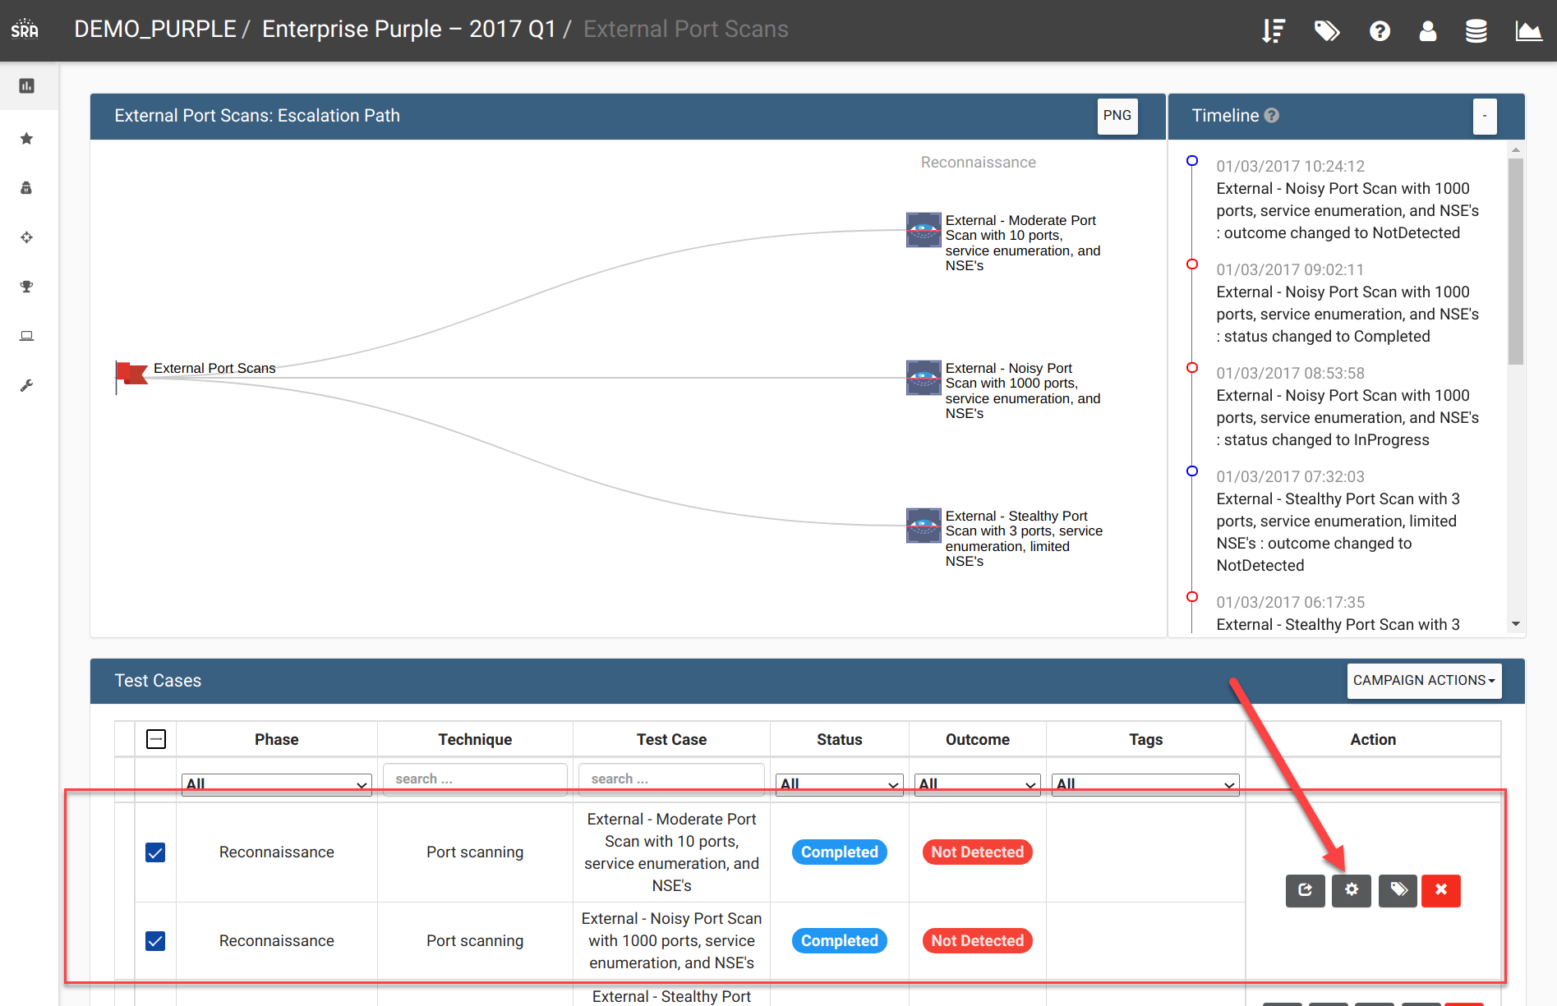

This will bring up the Bulk Edit screen. You can enable a field replacement by selecting the checkbox on the left followed by the appropriate action you want to perform. In the following, I’m going to add a tag called “Testing Tag” to both of the Test Cases:

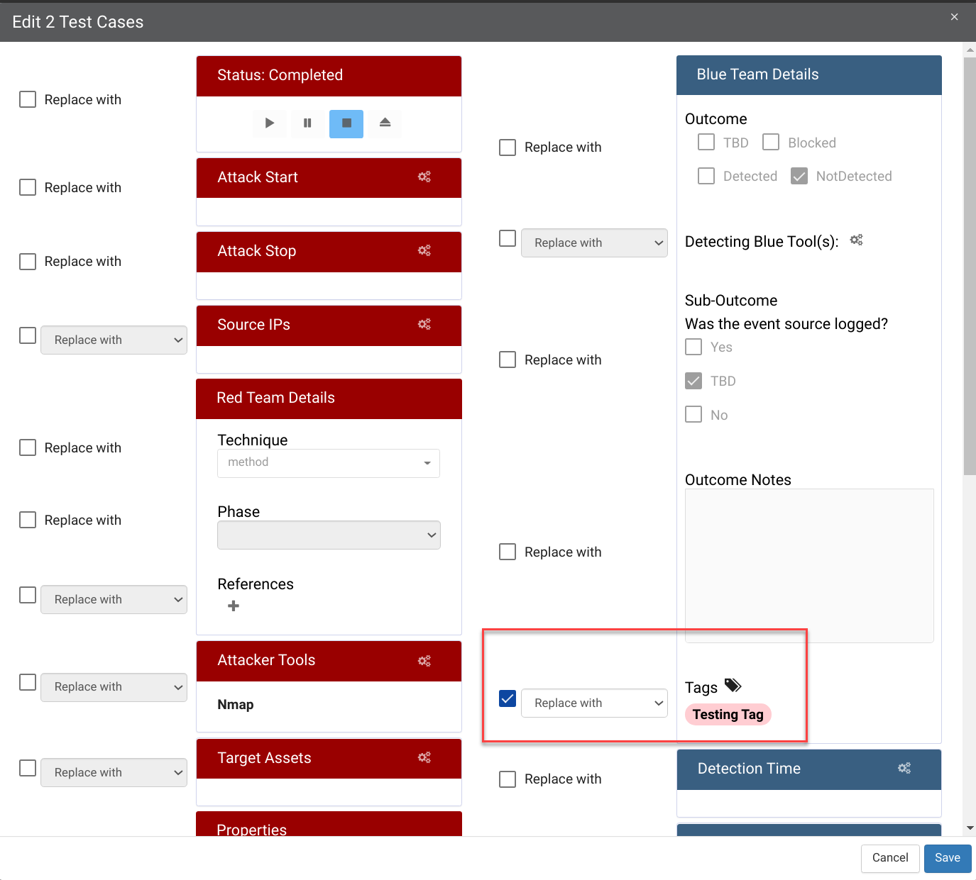

After clicking “Save”, the edits will appear on the Campaign Screen:

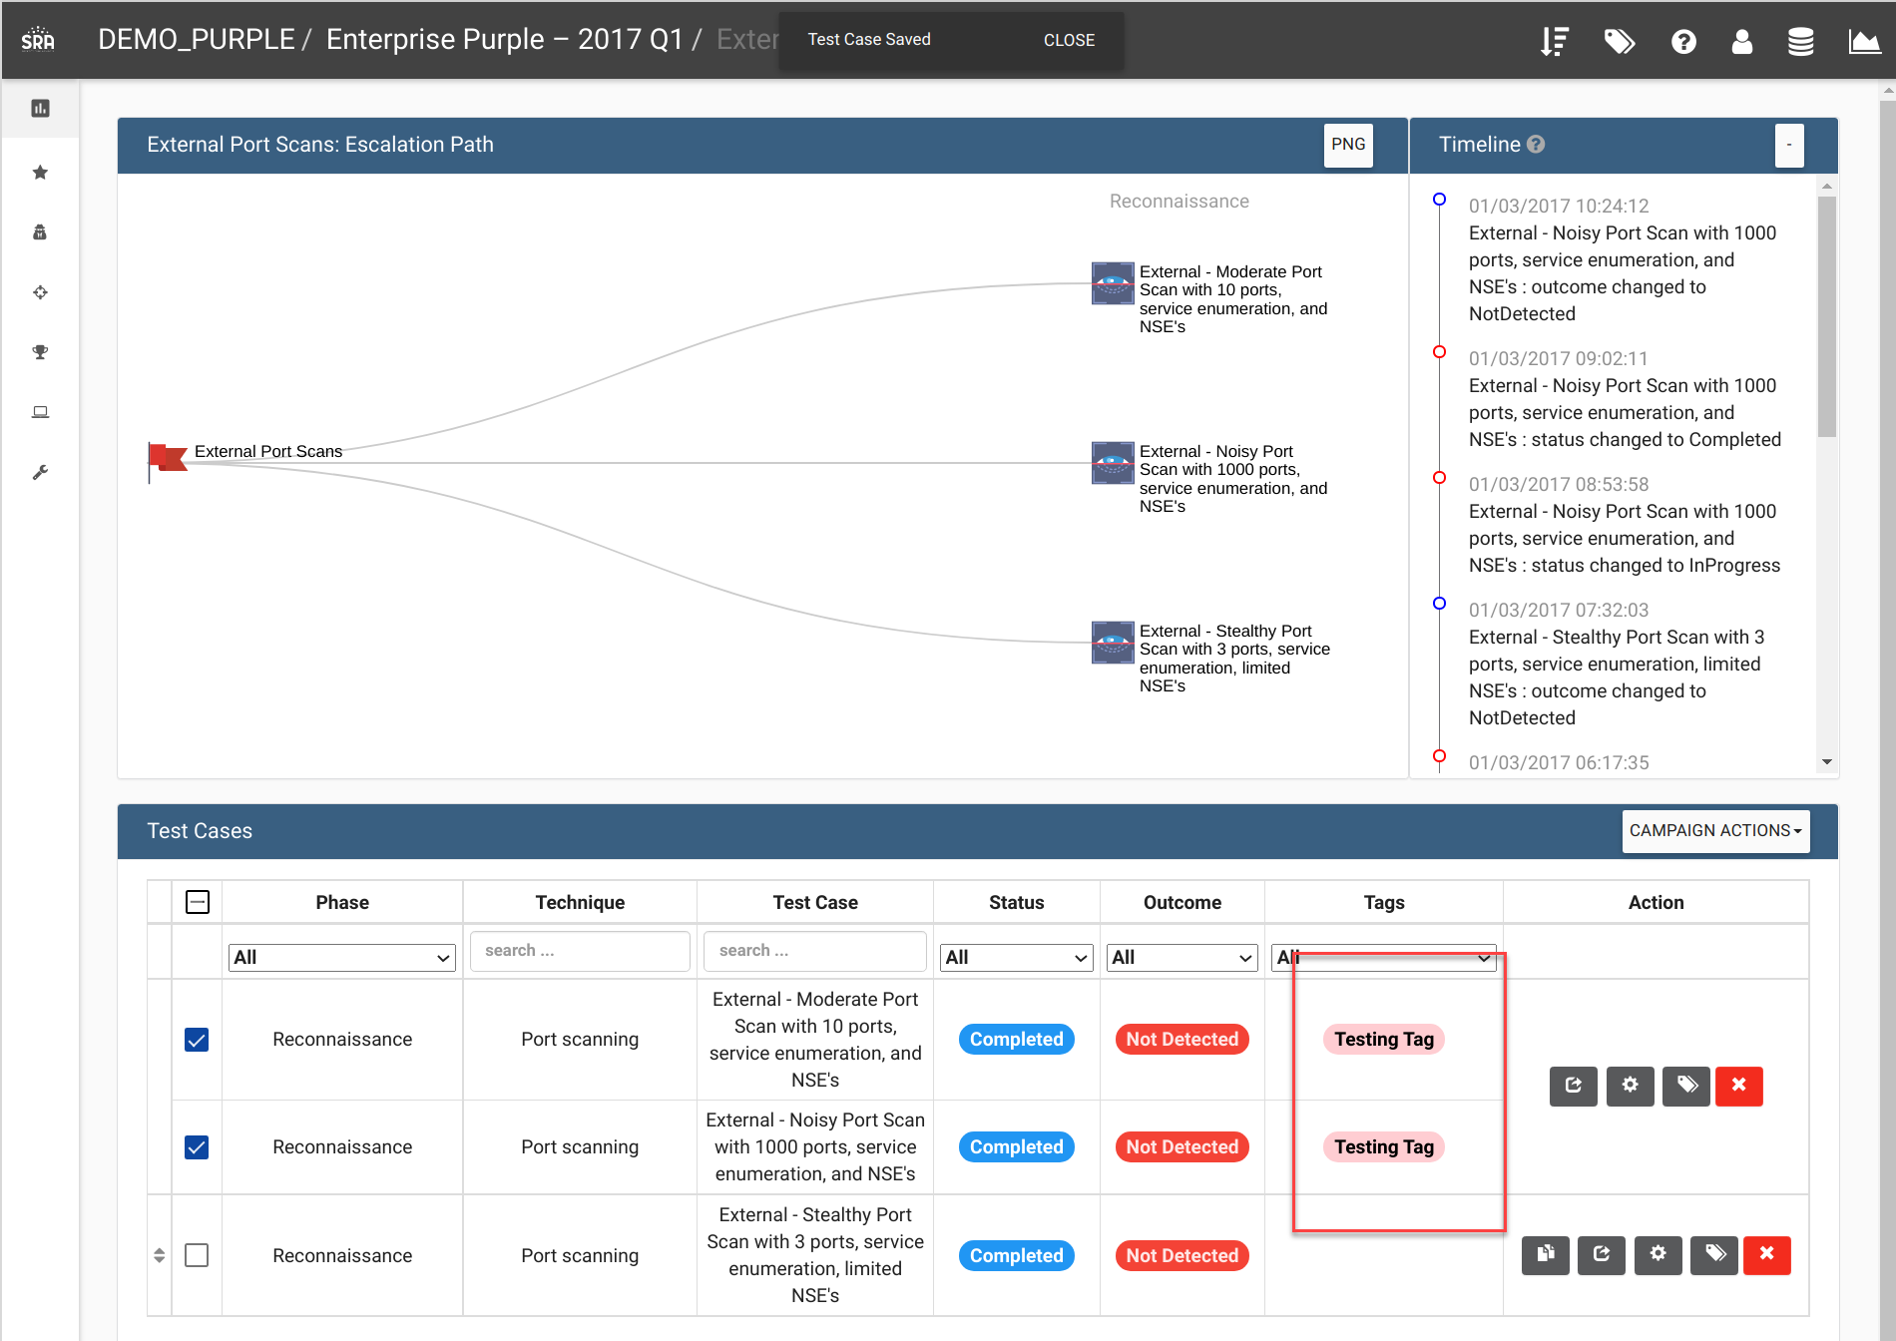

How can this feature help me?

This allows for some of the more tedious processes of filling out Test Cases to be streamlined.